Functional Specification
SAP User Creation Request Portal
Development based on OData Services · version 1.0 · 17.07.2026

1. Overview
The application is intended for creating and executing requests for new user accounts in SAP systems (ECC, HCM, BW, GRC). The portal user creates a request and specifies the User ID (format NK11022217), the organizational assignment and the required roles; no other user data is requested. No approval workflow is involved: once submitted, the request is passed directly to execution — the user account with the specified ID is created in the target system automatically.
After submission the requester sees the request in the “My Requests” list with its current status; the request page contains a visual status tracker (Draft → In Execution → Completed) and an execution log with the individual processing steps.

1.1 Technical Information
Attribute | Value
Application type | SAP Fiori application (freestyle SAPUI5), launched from the SAP Fiori Launchpad
UI technology | SAPUI5
Communication protocol | OData version 2 (V2)
OData service | ZUI_USER_REQUEST_SRV (SAP NetWeaver Gateway, transaction SEGW)
Authentication | Active Directory (AD) / Single Sign-On (SSO)

2. Process Description

2.1 Detail Flow Description
- User Login. The user logs into the portal using Active Directory (AD) / Single Sign-On (SSO).
- Request Entry. The user clicks “Create” and enters the User ID in the format NK11022217 (NK + 8 digits). No other user data is requested; the account will be created with the specified ID.
- Select Directorate. The system retrieves the list of directorates (OData: DirectorateSet); the user selects the applicable directorate.
- Select Department. Based on the selected directorate, the system displays the corresponding departments (DepartmentSet, filtered by DirectorateId).
- Select Position. The positions of the selected department are displayed (PositionSet); roles are derived from the position.
- Select Roles. The portal retrieves the roles mapped to the position (RoleSet); only active and authorized roles are displayed. Multiple roles can be selected within a single request.
- Request Details. The user specifies the access validity dates (“Valid From”, “Valid To”) and the business justification. The system validates mandatory fields before submission.
- Submission (Deep Create). The portal creates the request together with its role items in a single POST call (see section 2.3). The request receives a number (prefix USR) and the status “In Execution”.
- Execution. Background processing creates the user account with the name UserId in the target system (BAPI_USER_CREATE1) and assigns the roles (BAPI_USER_ACTGROUPS_ASSIGN). Every step is recorded in the execution log.
- Monitoring. The requester sees the active request in the list with status “In Execution”; the request page shows the status tracker and the execution log. Once processing is finished, the request receives the status “Completed” and the requester is notified. If a processing step fails, the request receives the status “Error”.

2.2 Status Model
Code | Status | Color (criticality) | Description
D | Draft | 0 — neutral | Request saved but not submitted; can be edited and deleted
P | In Execution | 2 — yellow | Request submitted; account creation and role assignment are being processed. The request can no longer be edited or cancelled
C | Completed | 3 — green | User account created; the requester has been notified
E | Error | 1 — red | Execution failed; the affected log step contains the system message. The requester and the administrator are notified
Once a request has been submitted, it cannot be edited or cancelled. Editing and deletion are possible only while the request is in status “Draft”. To request a correction, the user creates a new request (e.g. using the “Copy” action).
For instance-based control the UserRequest entity exposes the boolean flags Editable and Deletable (true only in status “Draft”). The Fiori application uses them to enable/disable the Edit and Delete actions; the Gateway service additionally validates both flags — Editable in CREATE_DEEP_ENTITY when an existing draft is updated, Deletable in DELETE_ENTITY.

2.3 Request Creation via Deep Create
The request is created with a single POST call on the root entity with the inline collection of roles (navigation property ToRoles). On the SAP side the call is handled by the CREATE_DEEP_ENTITY method of the DPC_EXT class: the request header and the role items are created in one LUW, the request number is generated, the status is set to “P” and background execution is started.
POST /sap/opu/odata/sap/ZUI_USER_REQUEST_SRV/UserRequestSet
{
"RequestType": "C",
"UserId": "NK11022217",
"DirectorateId": "50000100",
"DepartmentId": "50000250",
"PositionId": "60000310",
"ValidFrom": "/Date(1785542400000)/",
"Justification": "New employee, order No. 145-K",
"ToRoles": [
{ "RoleName": "Z_ECC_FI_DISPLAY" },
{ "RoleName": "Z_ECC_MM_BUYER" }
]
}

The service response returns the created request with its RequestId and the inline role items. Drafts (status D) are created with the same call using the “Draft” flag: execution is not started. Updating a draft also goes through CREATE_DEEP_ENTITY — the call carries the existing RequestId, and the header together with the role items is replaced in one LUW.

3. Data Model (OData Entities)
Service: ZUI_USER_REQUEST_SRV (OData V2). The root entity is UserRequest; the request items (roles) and the execution log are dependent entities linked via navigation properties.

3.1 UserRequest — Request (Root Entity)
Field | Type (EDM) | Length | Req. | Description
RequestId | Edm.String | 12 | Key | Request number, generated automatically (number range, prefix USR)
RequestType | Edm.String | 1 | Yes | Request type: C — user creation
Status | Edm.String | 1 | Yes | Status code (see section 2.2)
StatusText | Edm.String | 30 | — | Status text for display
StatusCriticality | Edm.Byte | — | — | Status color code: 1 red, 2 yellow, 3 green, 0 neutral
UserId | Edm.String | 10 | Yes | User ID — the name of the account to be created. Format NK + 8 digits (regex ^NK\d{8}$). Availability check against USR02. No other user data is requested or derived
DirectorateId | Edm.String | 8 | Yes | Directorate ID (org. structure object O)
DepartmentId | Edm.String | 8 | Yes | Department ID (object O, subordinate to the directorate)
PositionId | Edm.String | 8 | Yes | Position ID (object S, assigned to the department)
ValidFrom | Edm.DateTime | — | Yes | Access validity start
ValidTo | Edm.DateTime | — | No | Access validity end (default 31.12.9999)
Justification | Edm.String | 255 | Yes | Business justification
CreatedBy | Edm.String | 12 | — | Requester
CreatedAt | Edm.DateTime | — | — | Creation date/time
ChangedBy | Edm.String | 12 | — | Last changed by
ChangedAt | Edm.DateTime | — | — | Last change date/time
Editable | Edm.Boolean | — | — | Instance control flag for the UI: true only in status “Draft” — the request can be edited
Deletable | Edm.Boolean | — | — | Instance control flag for the UI: true only in status “Draft” — the request can be deleted

Navigation properties: ToRoles (1..n RequestRole), ToExecutionSteps (1..n ExecutionStep).

3.2 RequestRole — Roles of the Request
Field | Type (EDM) | Length | Req. | Description
RequestId | Edm.String | 12 | Key | Request number
RoleName | Edm.String | 30 | Key | Technical role name (AGR_NAME)
RoleText | Edm.String | 80 | — | Role description
ValidFrom | Edm.DateTime | — | — | Role validity start (inherited from the request)
ValidTo | Edm.DateTime | — | — | Role validity end

3.3 ExecutionStep — Execution Log
Field | Type (EDM) | Length | Req. | Description
RequestId | Edm.String | 12 | Key | Request number
StepNo | Edm.String | 2 | Key | Step number (01–03)
StepText | Edm.String | 60 | — | Step name: data validation / account creation / role assignment
Result | Edm.String | 1 | — | Result: S — success, E — error, P — in progress, W — pending
ResultText | Edm.String | 30 | — | Result text
Message | Edm.String | 255 | — | System message (error text when Result = E)
ExecutedAt | Edm.DateTime | — | — | Step execution date/time

3.4 Value Help Entities
Entity | Key | Fields | Source
Directorate | DirectorateId | DirectorateId, DirectorateText | OM org. structure (HRP1000, object O, top level)
Department | DepartmentId | DepartmentId, DirectorateId, DepartmentText | HRP1000/HRP1001 — departments of the selected directorate (relationship B002)
Position | PositionId | PositionId, DepartmentId, PositionText | HRP1000/HRP1001 — positions of the department (object S, relationship B003)
Role | RoleName | RoleName, RoleText, PositionId | Role catalog (AGR_DEFINE/AGR_TEXTS) + position-to-role mapping table
Status | Status | Status, StatusText | Request status domain

3.5 Service Operations
Operation | Implementation | Description
Request creation (Deep Create) | CREATE_DEEP_ENTITY | Creates the header and roles in a single call; generates the number; sets status P; starts background execution
Draft saving | CREATE_DEEP_ENTITY (Draft = X) | The request is created in status D without starting execution; it can be changed and deleted
Draft update | CREATE_DEEP_ENTITY (with existing RequestId, Draft = X) | Changing a draft is performed by the same deep create call: the header and the role items are replaced in one LUW. Allowed only while Editable = true (status D), otherwise the service returns an error
Request deletion | DELETE_ENTITY | Deleting a draft; allowed only while Deletable = true (status D), otherwise the service returns an error
Reading a request with items | GET_EXPANDED_ENTITY ($expand=ToRoles,ToExecutionSteps) | Request page: header data, roles, execution log

4. Screen Design

4.1 “My Requests” List
The start screen. The user sees all own requests; active ones are shown first. The “Status” column is displayed with a colored indicator; the “User ID” column shows the name of the account to be created. The “Create” button opens the new request form. The “Delete” button is enabled only when a request in status “Draft” is selected (instance flag Deletable = true); for all other statuses it is disabled.
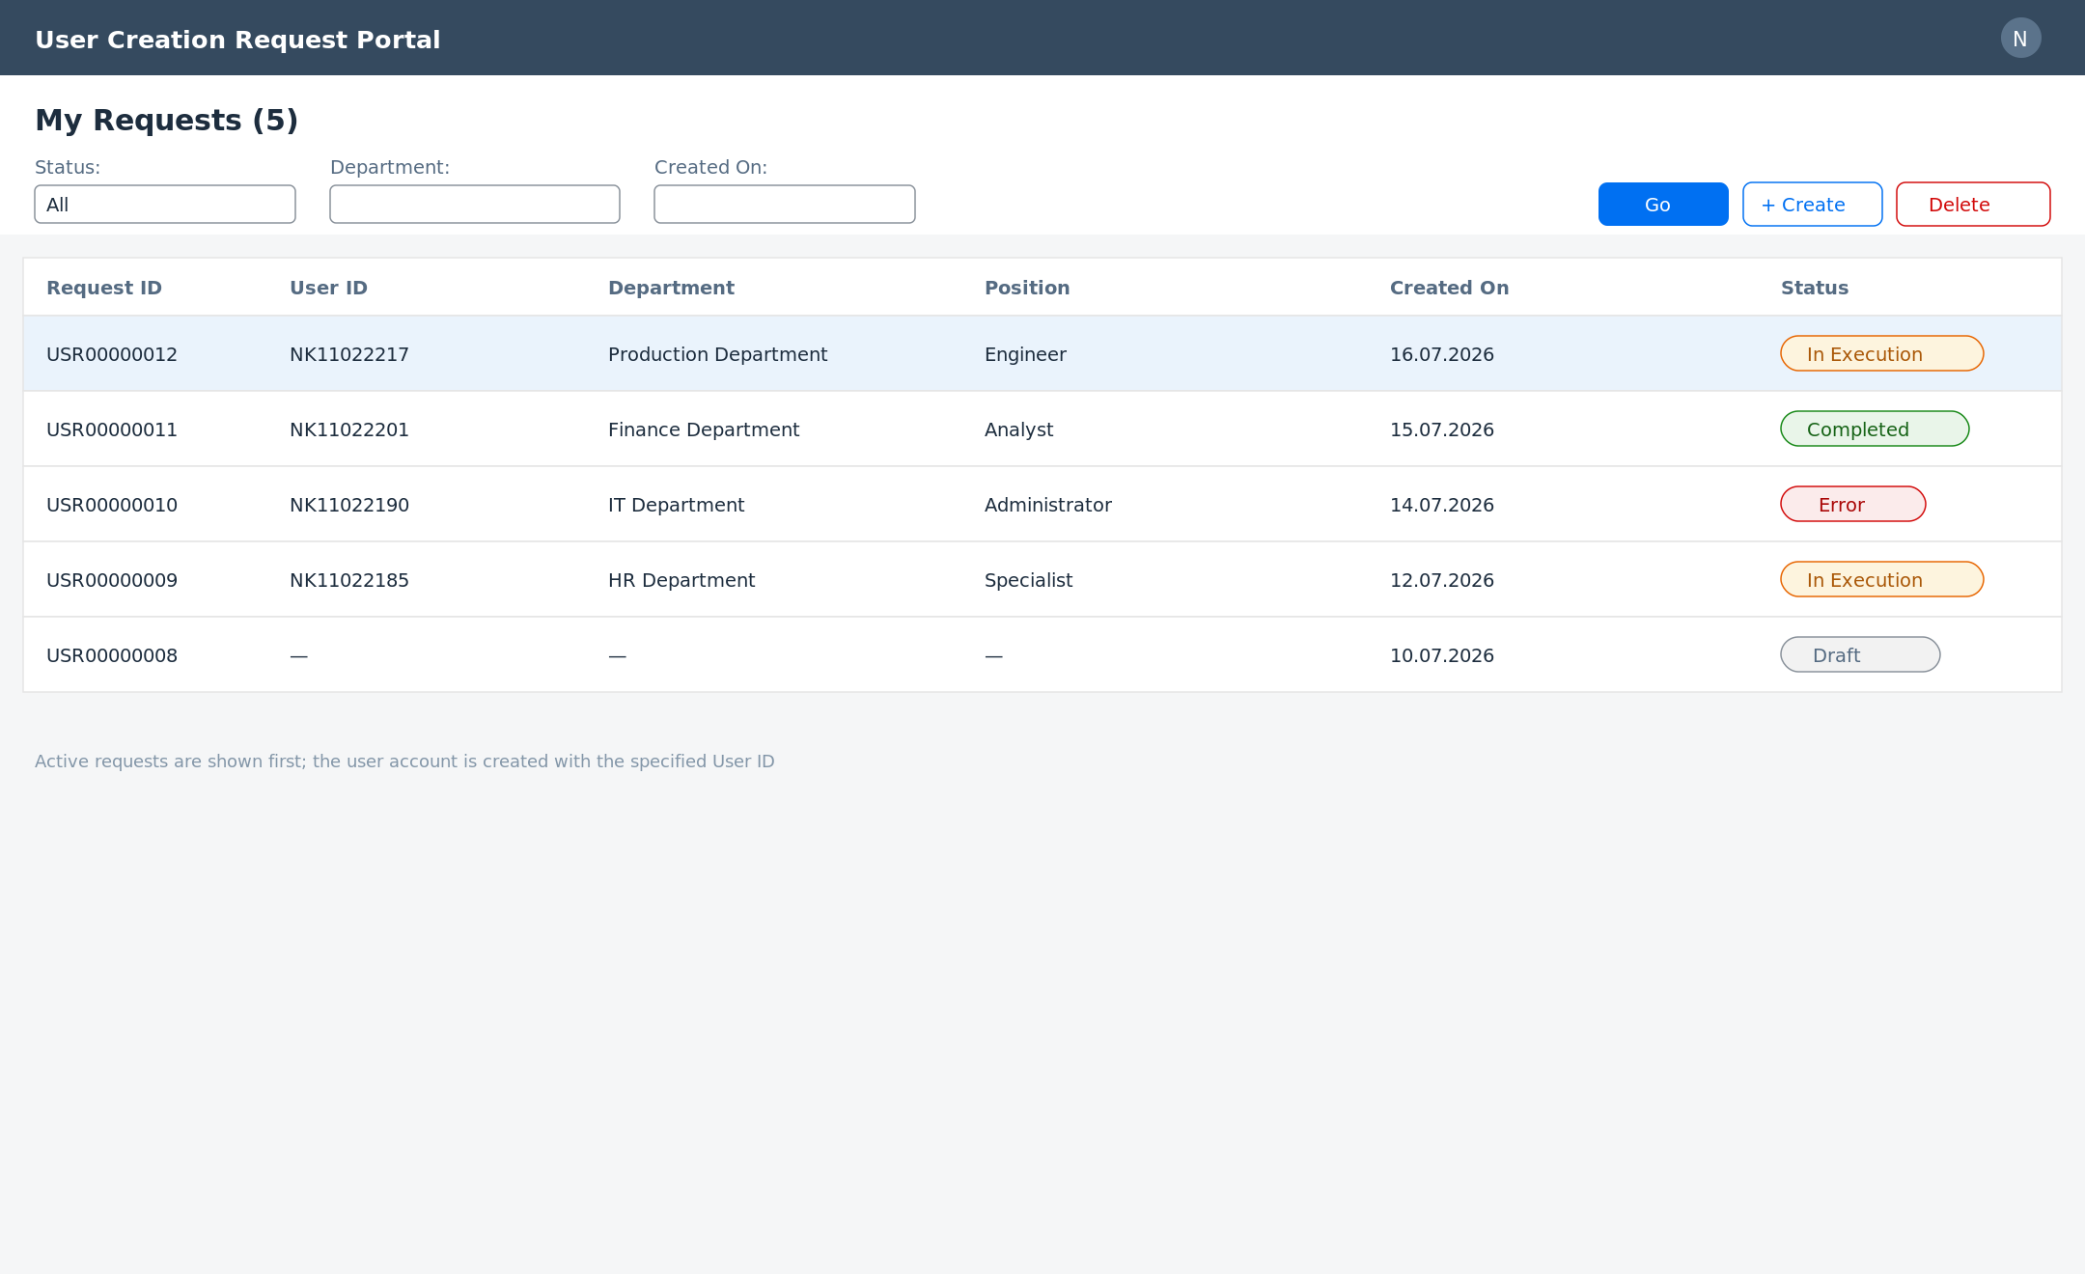
Fig. 1. Request list with statuses

4.2 Request Creation Form
The form consists of four sections: User ID (format NK + 8 digits, format and availability check), organizational data (cascading selection directorate → department → position), access (validity dates, roles by position) and justification. The “Submit” button performs the deep create and starts execution; “Save Draft” stores the request without submission.
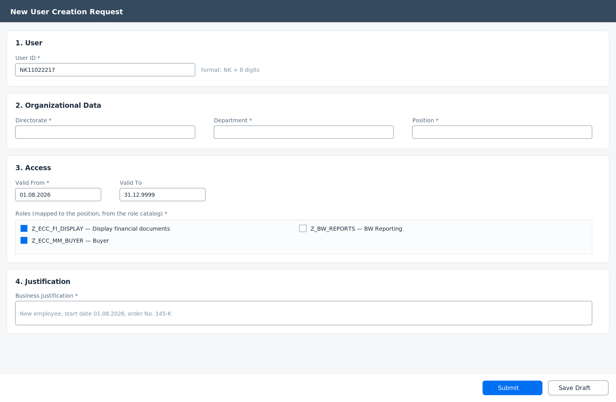
Fig. 2. Request creation form

4.3 Request Page (Status Monitoring)
After submission the requester opens the request page: at the top — the colored status badge and the status tracker (Draft → In Execution → Completed); below — the request details and the execution log with step results. The “Copy” action creates a new request based on the current one.
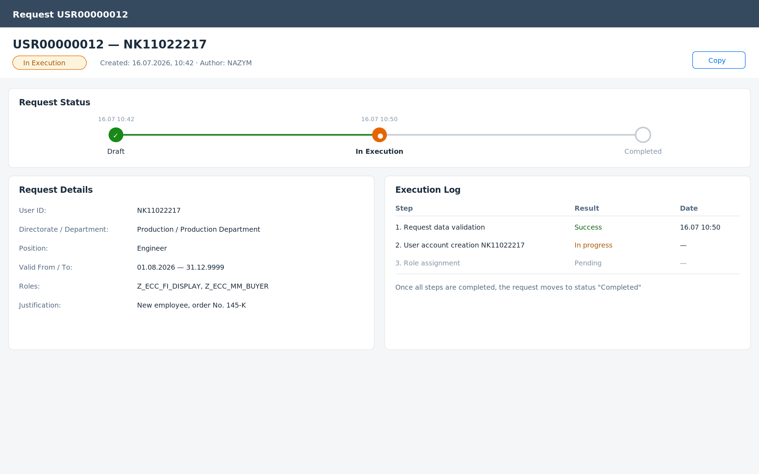
Fig. 3. Request page with status tracker and execution log

5. Integration and Notifications
- User account creation: BAPI_USER_CREATE1 in the target system via RFC.
- Role assignment: BAPI_USER_ACTGROUPS_ASSIGN.
- Org. structure: reading objects O/S from HRP1000, HRP1001 (relationships B002/B003).
- Execution runs in the background (bgPF / job) immediately after the request is created; every step is written to the execution log.
- Notifications: to the requester — when the request is completed and in case of an error; to the administrator — in case of an execution error.
- The initial password is generated by the target system and handed over to the user according to the company procedure (outside the portal).

6. Data Selection (Table/Field Details)
Table | Description
ZUSR_REQUEST | Request header (fields correspond to the UserRequest entity)
ZUSR_REQ_ROLE | Request roles (RequestRole)
ZUSR_EXEC_LOG | Execution log (ExecutionStep)

